

Market Twin User Manual
  - AI Launch Simulation · Official User Guide
Mr.AI Inc. (주식회사 미스터에이아이)
Published June 2026 · Document v1.0

Document Information 4
1. Introduction 5
1.1 Overview 5
1.2 Core Value 5
1.3 Who It’s For 5
1.4 Requirements 5
2. Getting Started 6
2.1 Access & Sign-up 6
2.2 Email Verification 6
2.3 Login 6
3. Dashboard 8
3.1 First Sign-up — Sample Demo 8
3.2 Metric Cards (after running a simulation) 8
3.3 Starting a New Project 9
4. Creating a Project (6-step wizard) 10
4.1 Step 1 — Product 10
4.2 Step 2 — Price & Goal 11
4.3 Step 3 — Target Markets 12
4.4 Step 4 — Competitors (optional) 13
4.5 Step 5 — Creative (optional) 14
4.6 Step 6 — Review & Run 15
5. Running the Simulation 16
6. Reading Results 17
6.1 Personas Tab 17
6.2 Market Analysis Tab 18
6.3 Pricing Tab 19
6.4 Decision Tab 20
6.5 Risk Tab 20
6.6 Actions Tab 21
6.7 Beta Feedback 21
7. Asking a Persona 22
8. PDF Reports 23
9. Settings 25
10. Frequently Asked Questions (FAQ) 26
11. Troubleshooting 27
12. Glossary 28
13. Support & Contact 29

Document Information
Item | Detail
Document | Market Twin User Manual
Product | Market Twin (AI Launch Simulation)
Version | v1.0
Published | June 2026
Publisher | Mr.AI Inc. (주식회사 미스터에이아이)
Contact | contact@markettwin.ai
Audience | Marketing, strategy, and management leads validating an overseas launch with Market Twin
Revision history
Version | Date | Notes
v1.0 | 2026-06 | Initial release

1. Introduction

1.1 Overview
Market Twin is a SaaS that lets you validate an overseas launch with a simulation — before you ship. AI personas, modeled on government statistics for each candidate country’s local consumers, react to your product, price, and creative.
Where traditional market research takes weeks to months and costs tens of thousands of dollars, Market Twin delivers the following in just a few minutes:
- Which country to enter first (recommended markets)
- How local consumers react to your product and price
- What the right price is
- What the risks and go-to-market strategy are

1.2 Core Value
Value | Description
Launch success score | 0–100 score based on demand, CAC, and competitive intensity
Multi-country comparison | Objective comparison grounded in government statistics (KOSIS, BLS, e-Stat)
AI persona simulation | Precise analysis down to occupation, income band, and purchase intent
Regulatory pre-check | Markets where the product can’t legally be sold are excluded automatically

1.3 Who It’s For
Founders, marketing/strategy leads, export managers at SMEs and startups preparing to go global, plus accelerators and investors. Designed so that non-technical users can run it with 5 minutes of input.

1.4 Requirements
- Access: Web browser (latest Chrome, Edge, or Safari recommended); no installation
- URL: app.markettwin.ai
- Languages: Korean / English (switch in Settings)

2. Getting Started

2.1 Access & Sign-up
- Go to app.markettwin.ai in your browser.
- Choose a sign-up method on the login screen.
  - Continue with Google: instant sign-up/login with a Google account
  - Email/password: enter an email and a password (8+ characters)
- Agree to the Terms, Privacy Policy, and cross-border transfer notice (required) to finish.
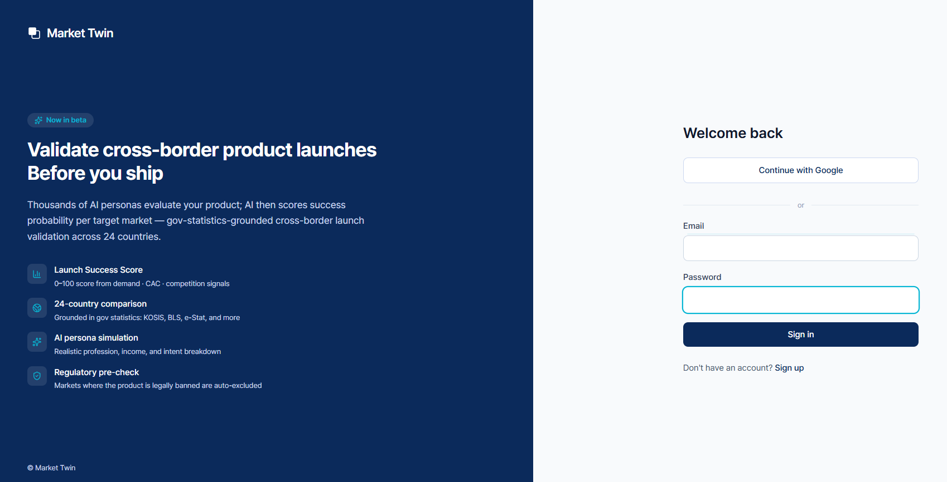
Login / product intro screen

2.2 Email Verification
If you signed up by email, email verification is required for security.
- Right after sign-up, a “Verify your email” screen appears.
- Click the link in the verification email sent from noreply@markettwin.ai.
- Once verified, you’re logged in automatically.
No verification email? ① Check your spam folder, then ② click “Resend confirmation email” on the login/sign-up screen (60-second interval). If it still doesn’t arrive, contact contact@markettwin.ai.

2.3 Login
- Log in with the method you signed up with (Google or email).
- If you try to log in while unverified, you’ll see a prompt with a “Resend confirmation email” button.

3. Dashboard
After login, the Dashboard is your home screen. The left navigation (Dashboard · Projects · Reports · Billing · Team · Settings · Help) gives access to every feature.

3.1 First Sign-up — Sample Demo
On first sign-up, the dashboard shows a sample demo card. With a pre-filled K-product sample, click Start sample demo — no input needed — to see what an overseas-market analysis looks like in 2–3 minutes (3 per day, separate from your validation runs).
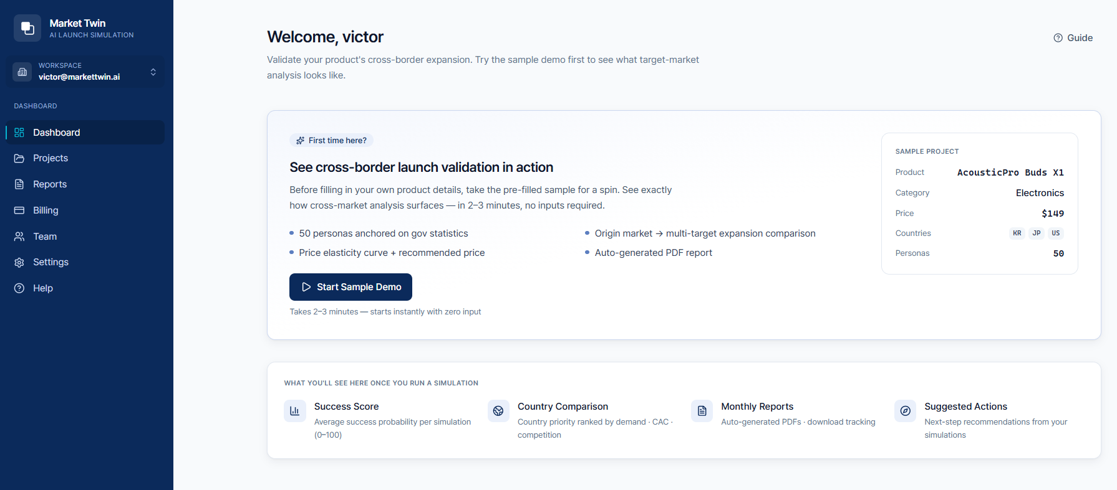
Dashboard — first-time user (sample demo)

3.2 Metric Cards (after running a simulation)
Once you run a simulation, the dashboard shows metric cards and a recent-projects list at the top.
Card | Meaning
Active projects | Number of projects currently running
Avg. success score | Average launch success score of completed simulations (0–100)
Countries tested | Number of countries used in analysis
Reports this month | Reports generated this month
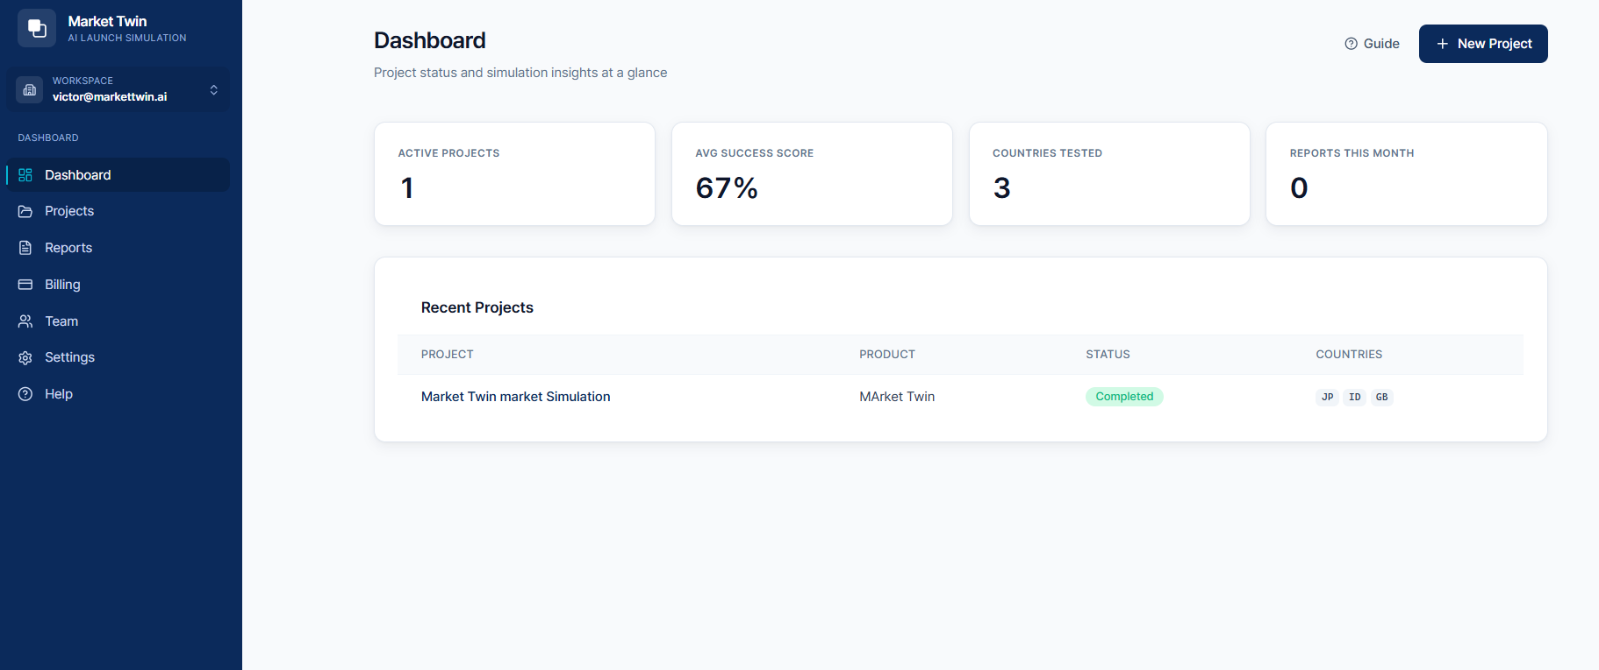
Dashboard — activity overview

3.3 Starting a New Project
To validate a real product, go to Projects in the left menu and click + New Project at the top right (see Chapter 4). After you run the sample demo once, + New Project also appears at the top right of the dashboard.
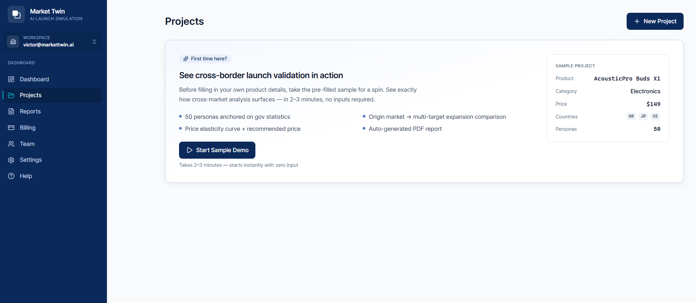
Projects screen — + New Project

4. Creating a Project (6-step wizard)
Enter your product over six steps. The progress bar at the top (1 Product → 2 Price & Goal → 3 Target Markets → 4 Competitors → 5 Creative → 6 Review & Run) shows where you are.
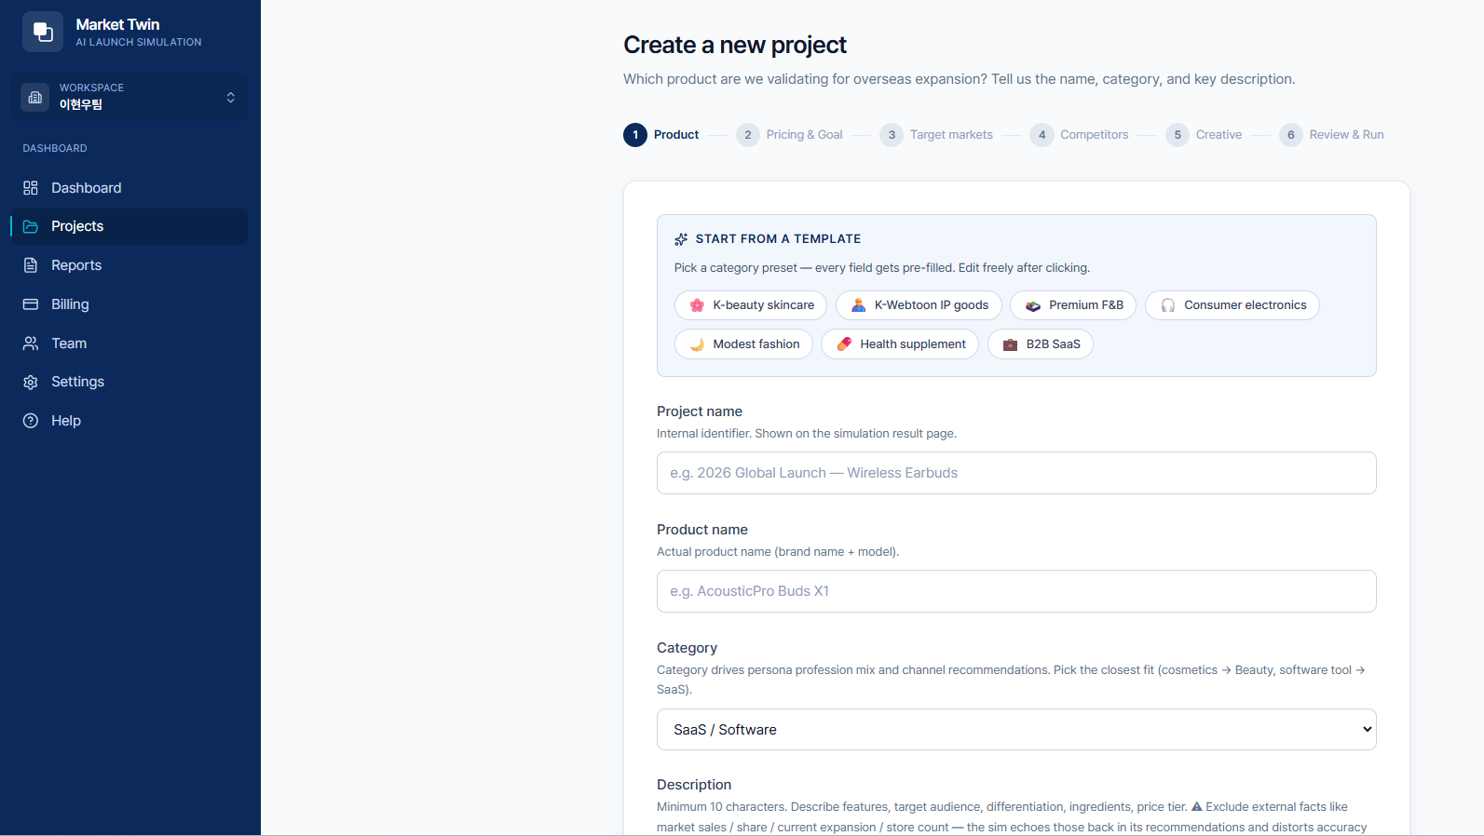
New project — start screen (template selection)
Tip — start from a template: Click a category preset at the top (K-beauty skincare / K-webtoon IP goods / premium food & beverage / premium appliance / modest fashion / health supplement / B2B SaaS) to auto-fill every field with an example. Edit freely afterward.

4.1 Step 1 — Product
Field | Description
Project name | Internal label. Shown on the results page.
Product name | Actual brand/model name
Category | Affects persona occupation distribution and channel recommendations. Pick the closest match.
Description | 10+ characters. Freely write features, target, differentiators, ingredients, price range.
Caution — leave out external facts. Do not enter market figures like “40% of sales in the US” (sales share, market position, current presence). The simulation takes them at face value and skews accuracy (e.g. “40% US sales” → it auto-recommends the US). Describe only the product itself for a more reliable market recommendation.
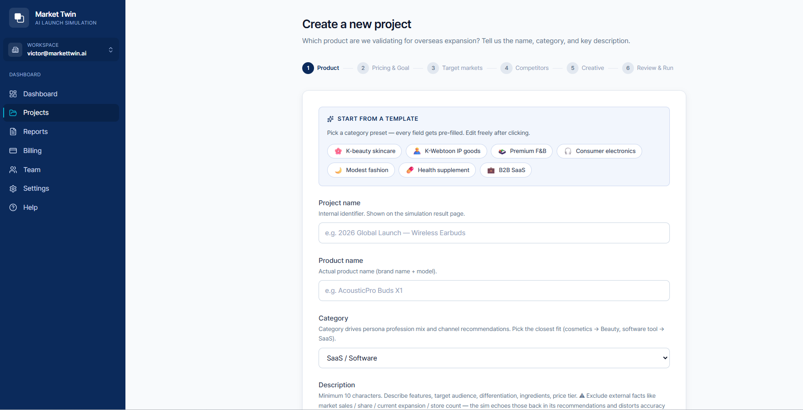
Step 1 — product details

4.2 Step 2 — Price & Goal
Field | Description
Base price + currency | Your current or candidate launch price. The simulation builds a price curve across a ±50% range.
Launch goal | Pick the top-priority KPI for this launch. It changes persona scenarios and channel recommendations.
Four launch goals
- Brand awareness — new-brand exposure and content reach
- Instant sales conversion — immediate revenue at launch, price optimization first
- Repeat & retention — repeat purchase / LTV, loyal-customer focus
- New-market entry — expanding from an existing market to new countries
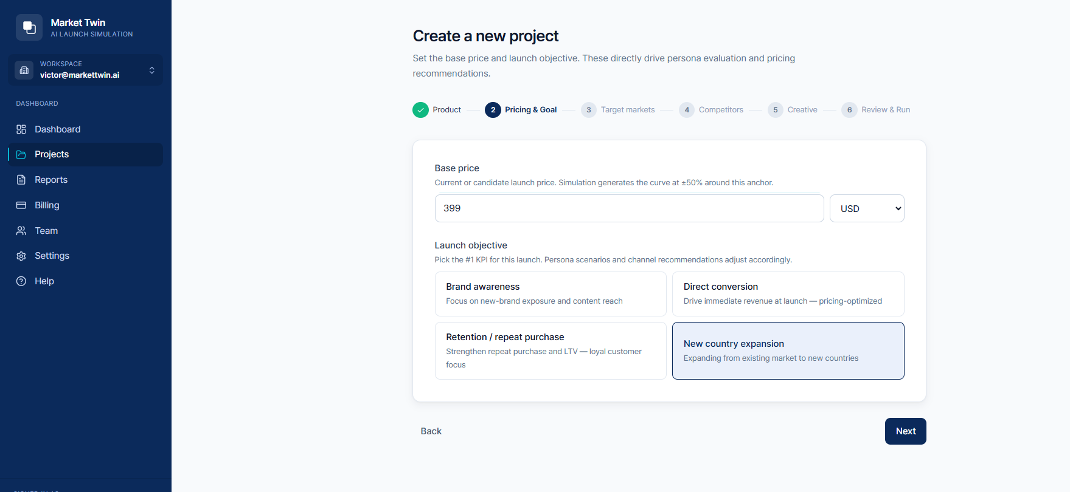
Step 2 — price & goal

4.3 Step 3 — Target Markets
Field | Description
Origin country | The home country your company launches/operates from. The simulation evaluates candidate markets relative to it. Default: South Korea.
Candidate markets | Pick one or more overseas markets to validate. Given cost/time, ~5 is recommended (24+ countries supported).
Adding your origin country to the candidates also yields a domestic score (for comparison with overseas options). However, the “Top-2 recommended markets” are chosen only from overseas candidates.
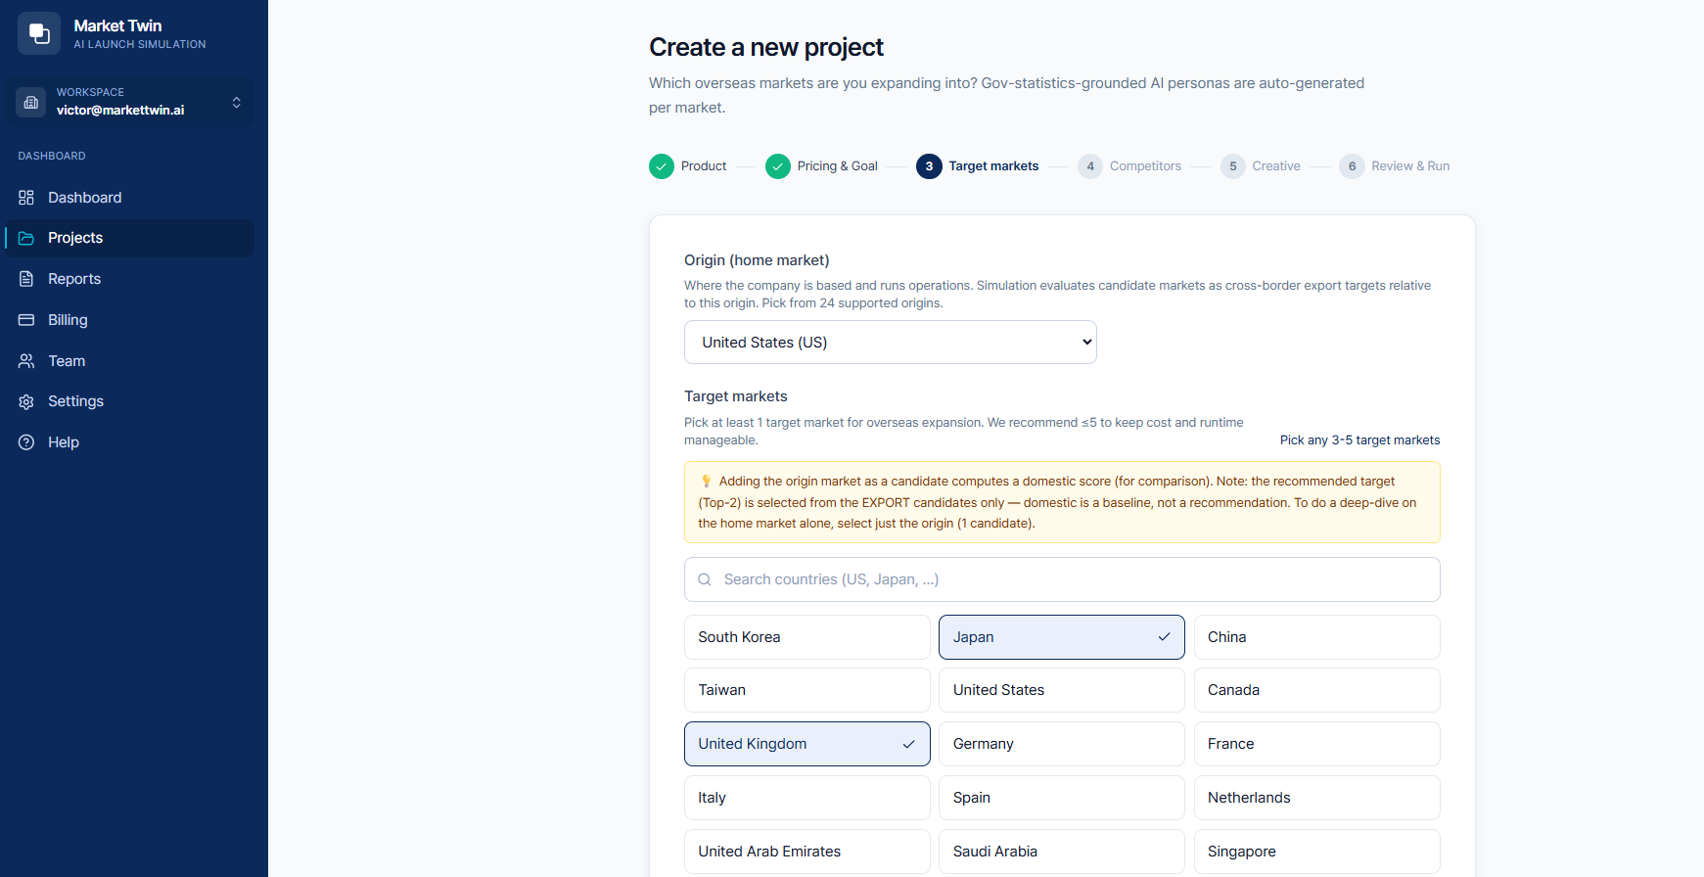
Step 3 — target market selection

4.4 Step 4 — Competitors (optional)
Field | Description
Competitor product/brand names | One per line. AI finds URLs and discovers 2–3 competitors you may have missed.
Competitor URLs | Only when you want a specific URL included. Leave blank and AI finds URLs from the names above.
The results screen distinguishes “what you entered” from “what AI discovered.” Competitor discovery adds 3–8 seconds to project creation.
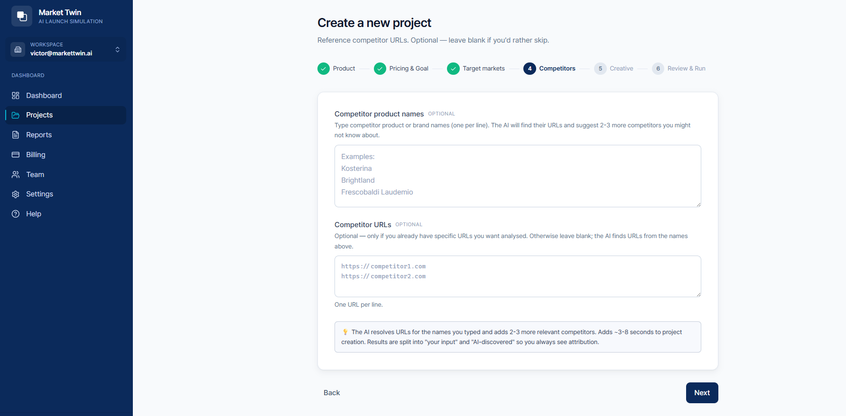
Step 4 — competitors

4.5 Step 5 — Creative (optional)
Field | Description
Creative concept | One per line, rough description, of concepts you’d run (or are considering). The results show a 0–100 score + per-market strengths/weaknesses per concept.
Mockup image upload | Upload a mockup (JPG/PNG/WebP/GIF, ≤4MB each). Vision-AI reads the actual visual for more accurate analysis.
Image URLs | Paste already-hosted public URLs, one per line, for the same effect.
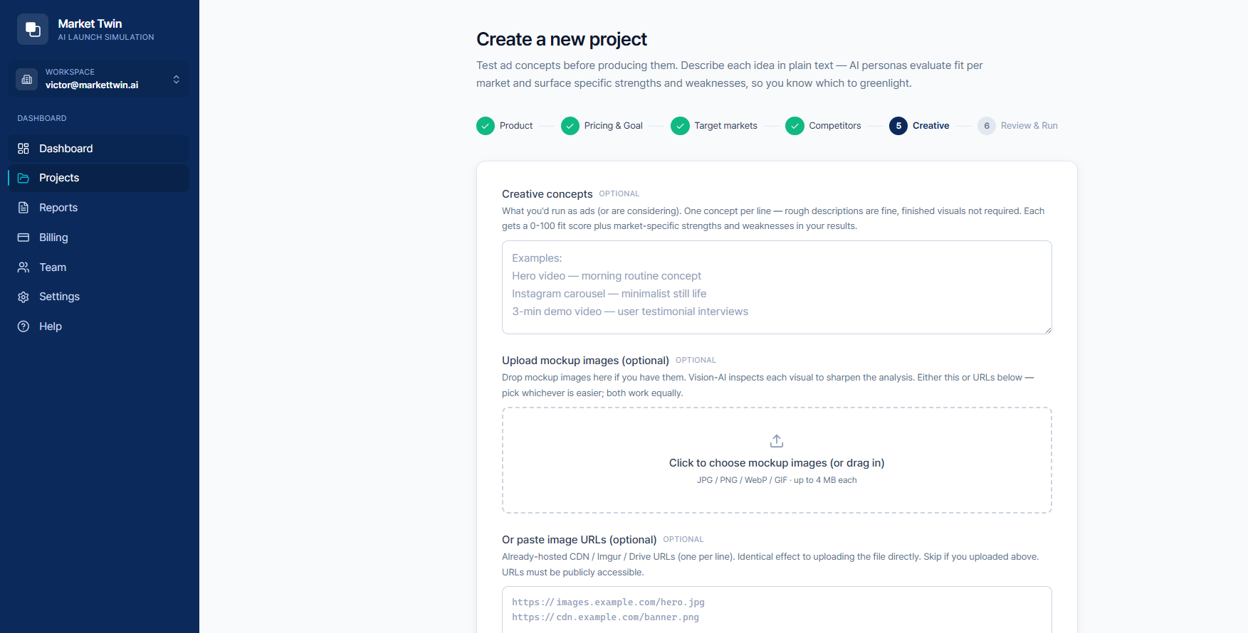
Step 5 — creative

4.6 Step 6 — Review & Run
Review the inputs and Run. Depending on the tier you chose, 600–10,000 AI personas start simulating across multiple LLMs.

5. Running the Simulation
When you run it, a progress screen appears. Multiple independent simulations run in parallel to produce a reliable result (the ensemble approach).
- Progress and completed-sim counts update in real time.
- Turn on browser notification on completion to be alerted while doing other work.
- You can close the screen — the simulation keeps running, and you’ll find results on the results page when done.
- Time: the sample demo takes 2–3 minutes; a real product validation usually a few minutes.
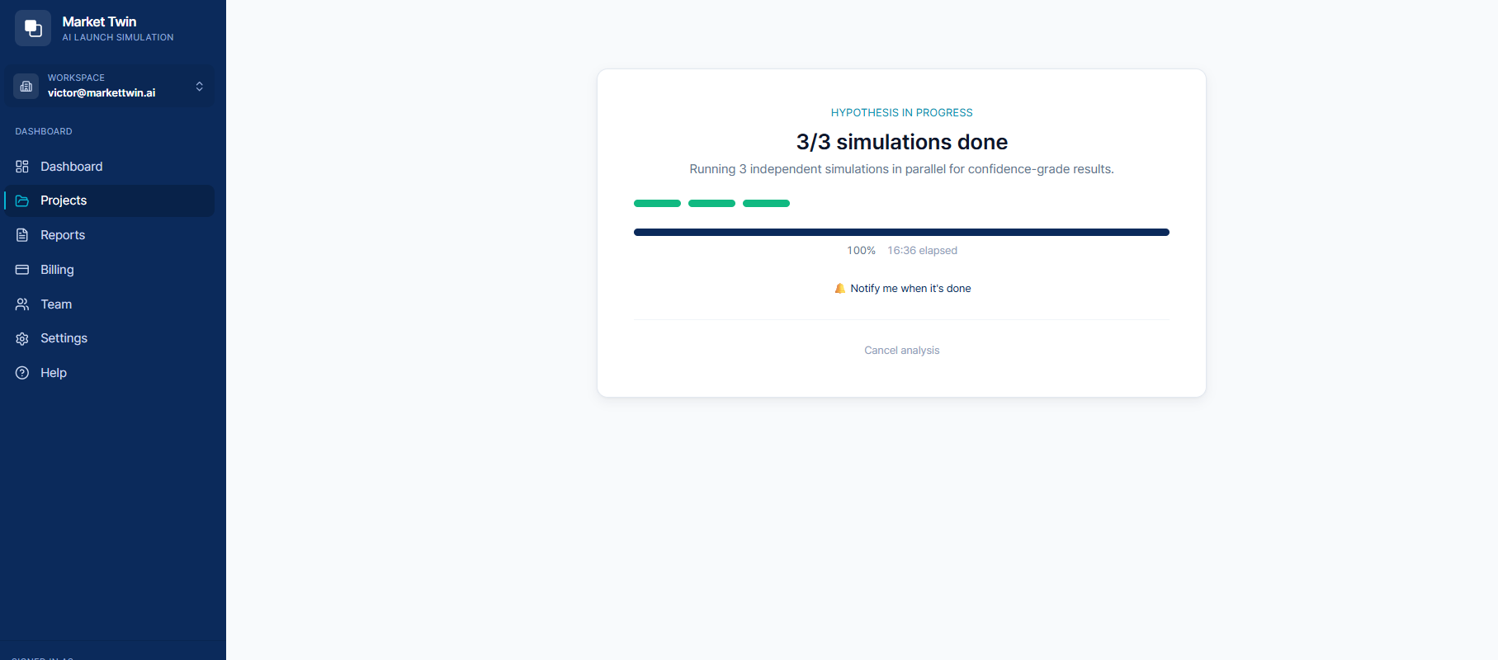
Simulation in progress / complete

6. Reading Results
The top of the results screen shows the tier, sim count, persona count, and LLMs used (e.g. Decision Plus · 15 sims · 3,000 personas · CLAUDE·GPT-4·DEEPSEEK), with results across 10 tabs below.
Tab | Content
Summary | Consensus narrative merging all sims
Overview | Key metrics summary
Countries | Per-country score and vote share
Market Analysis | Market size (TAM), growth trend, reachable segment, competitor analysis
Personas | Persona stats, purchase-intent distribution, positive/negative voices, age/occupation distribution
Pricing | Recommended price vs. your input, revenue index
Decision | Investment required, CAC, ROI, break-even
Risk | Overall risk level, individual risks
Actions | Impact × difficulty priority matrix
Data | Raw data

6.1 Personas Tab
Persona stats (total personas, average purchase intent, strong interest ≥70, weak interest <35), a purchase-intent histogram, average intent by country, and age/occupation distribution (Top 12).
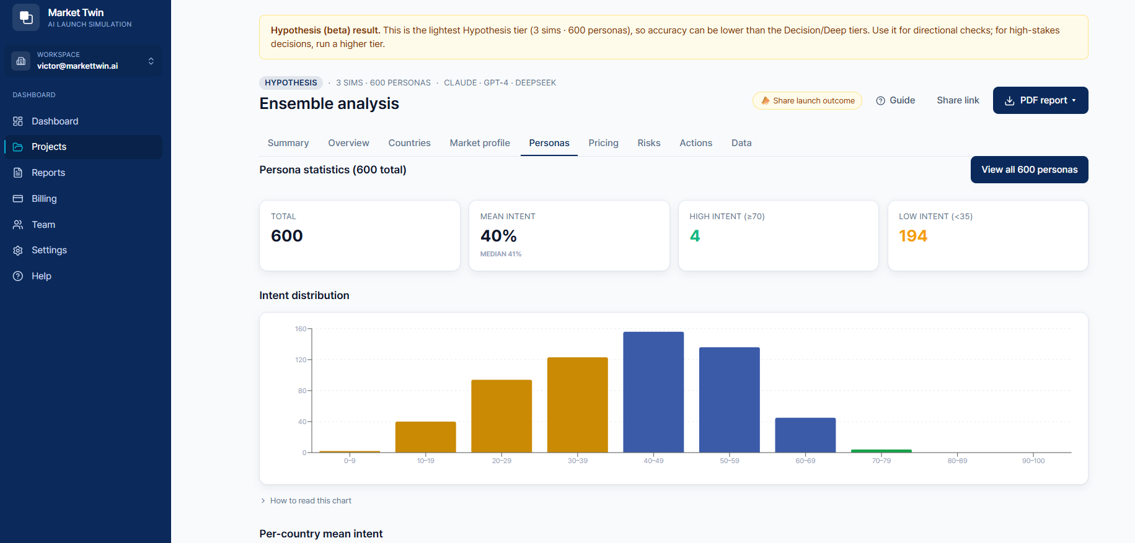
Results — persona stats & distribution
At the bottom, the positive personas’ voices and negative personas’ voices appear with first-person quotes and profiles (country, intent score, occupation, age). You can read directly what attracts real consumers and what makes them hesitate.
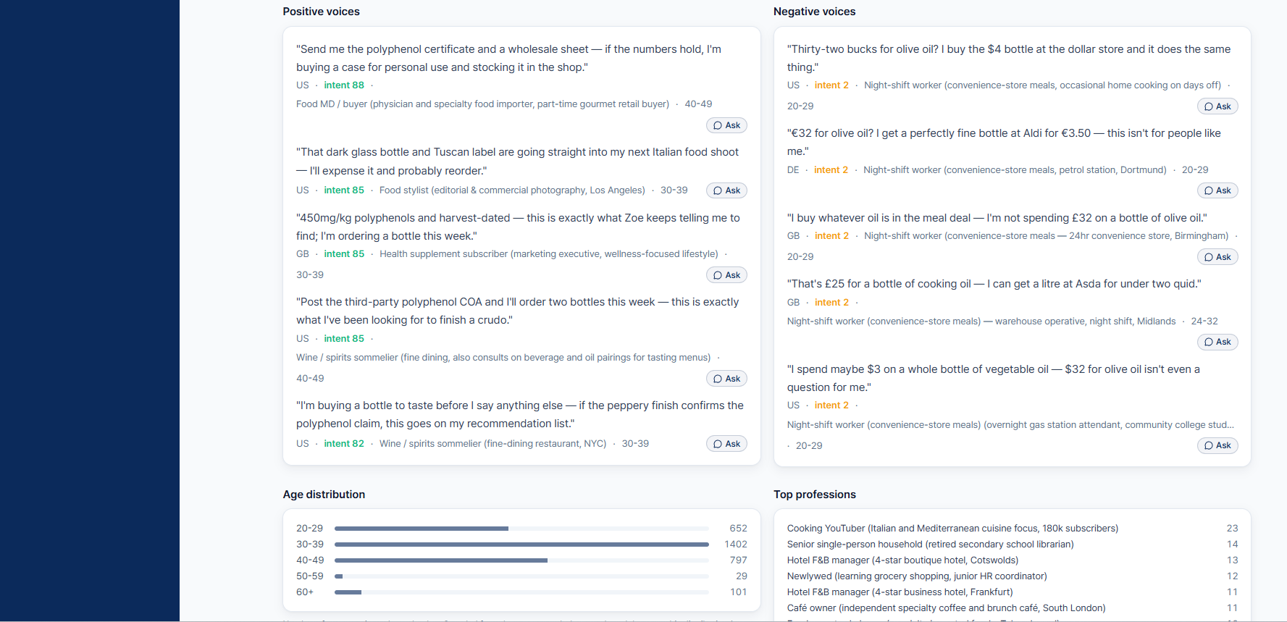
Results — positive/negative persona voices

6.2 Market Analysis Tab
Market size for the recommended country (TAM estimate, growth trend, reachable segment, with source links) plus competitor analysis. Each competitor is compared on threat level (high/medium/low), origin, overview, strengths, weaknesses, and price.
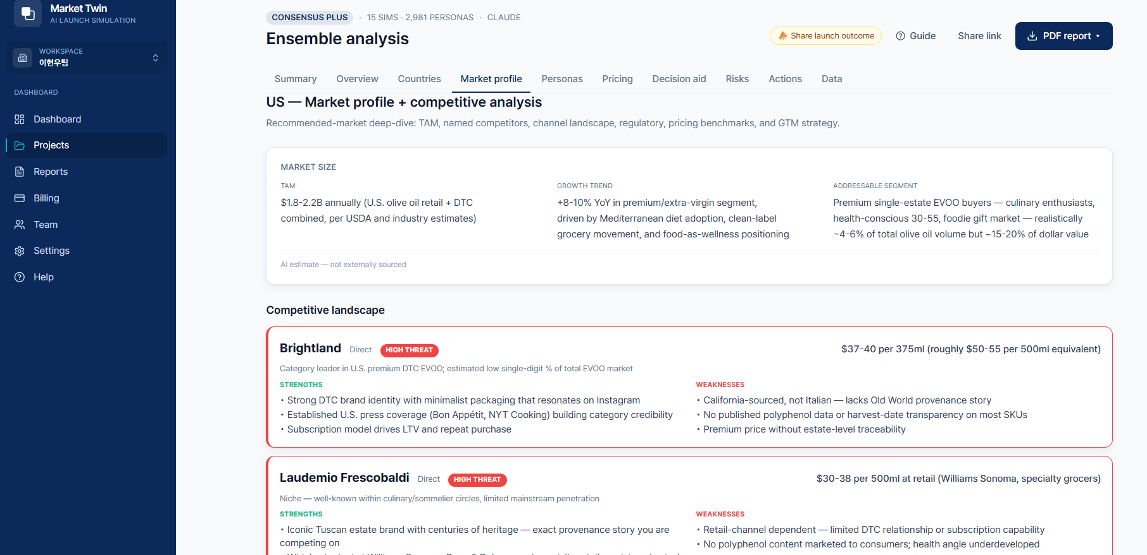
Results — market size & competitor analysis
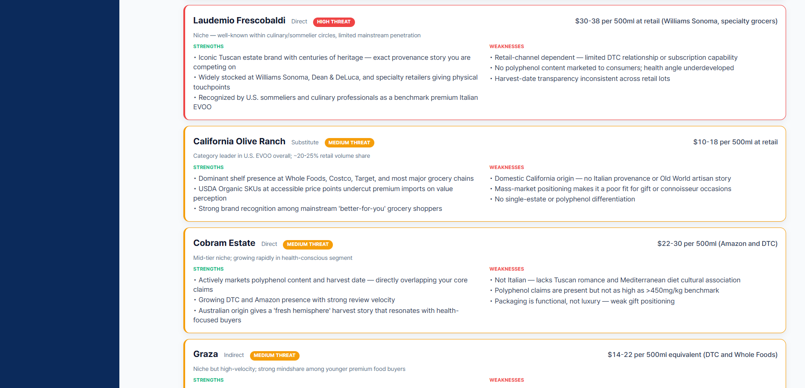
Results — competitor detail comparison

6.3 Pricing Tab
Recommended price (median across sims), the middle 50% band, a comparison of your input vs. LLM recommendation vs. the curve’s revenue-maximizing point, and a Top-5 revenue index (price × conversion) — validating the right price with data.
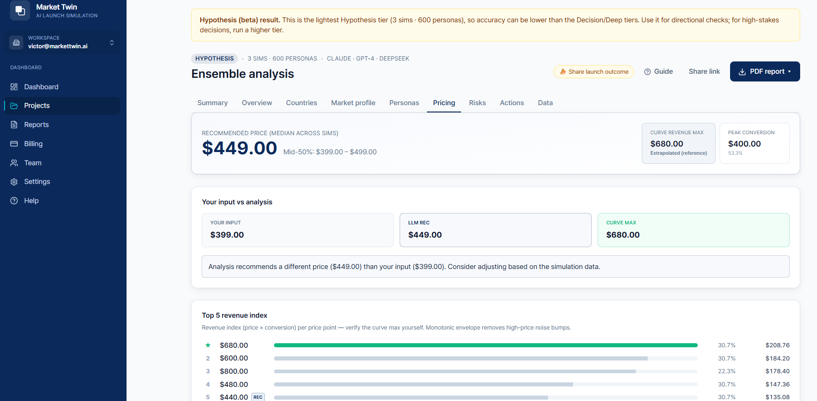
Results — price optimization

6.4 Decision Tab
Unit price, CAC (customer acquisition cost), M:R (marketing-to-revenue), marketing budget and expected revenue by customer count, and break-even scenarios — supporting your investment decision.
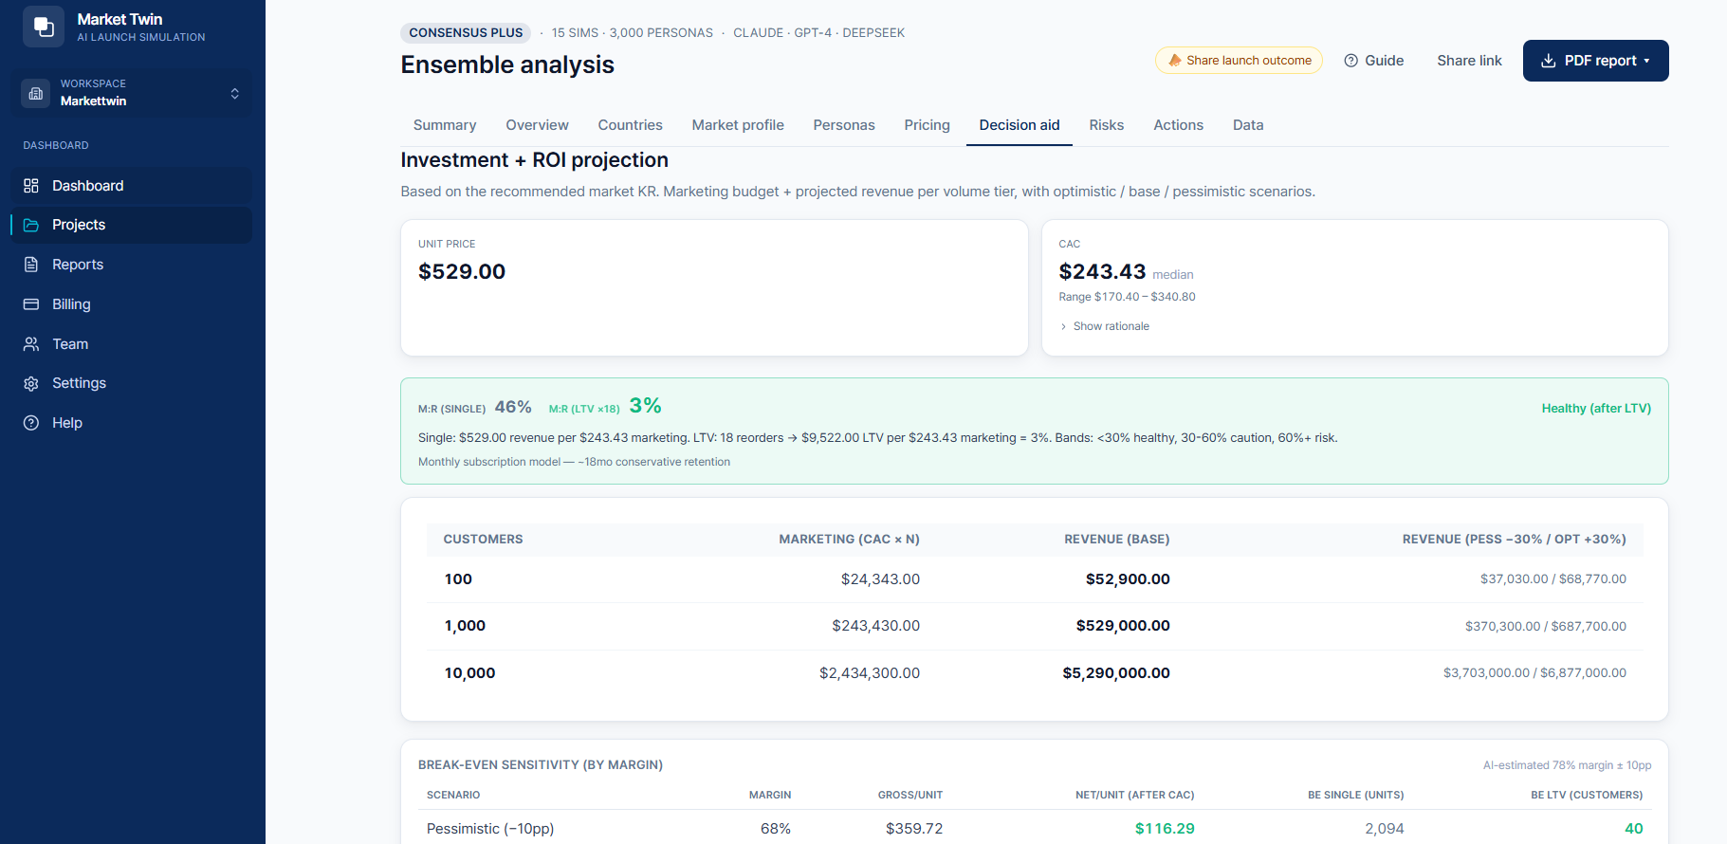
Results — investment required + ROI

6.5 Risk Tab
The overall risk level plus individual risks (HIGH/MEDIUM) with descriptions, the number of sims that surfaced them, and consensus rate. Identify, in priority order, the barriers to clear before launch.
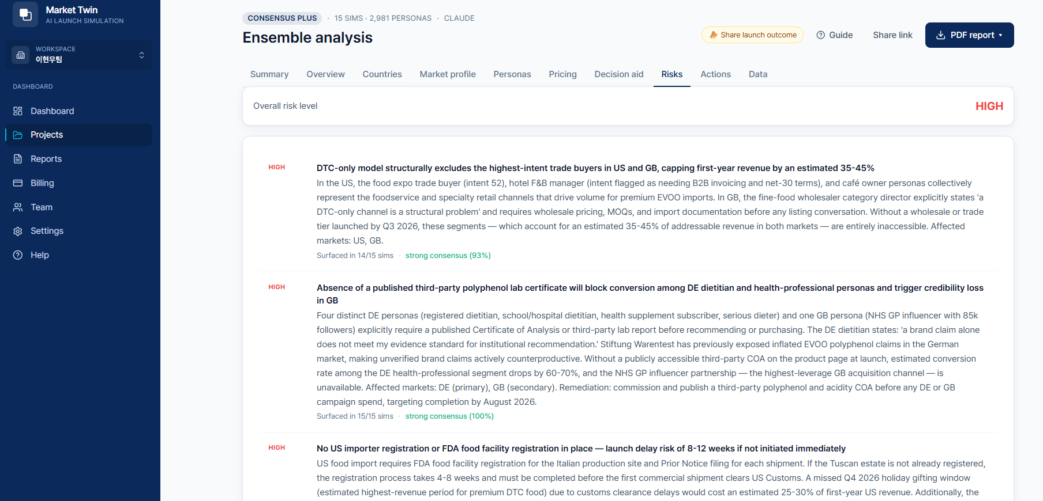
Results — risk analysis

6.6 Actions Tab
A priority matrix placing each action by impact (vertical) × difficulty (horizontal). Start top-left with Quick Wins (high impact, easy), then review Strategic / Marginal / Avoid.
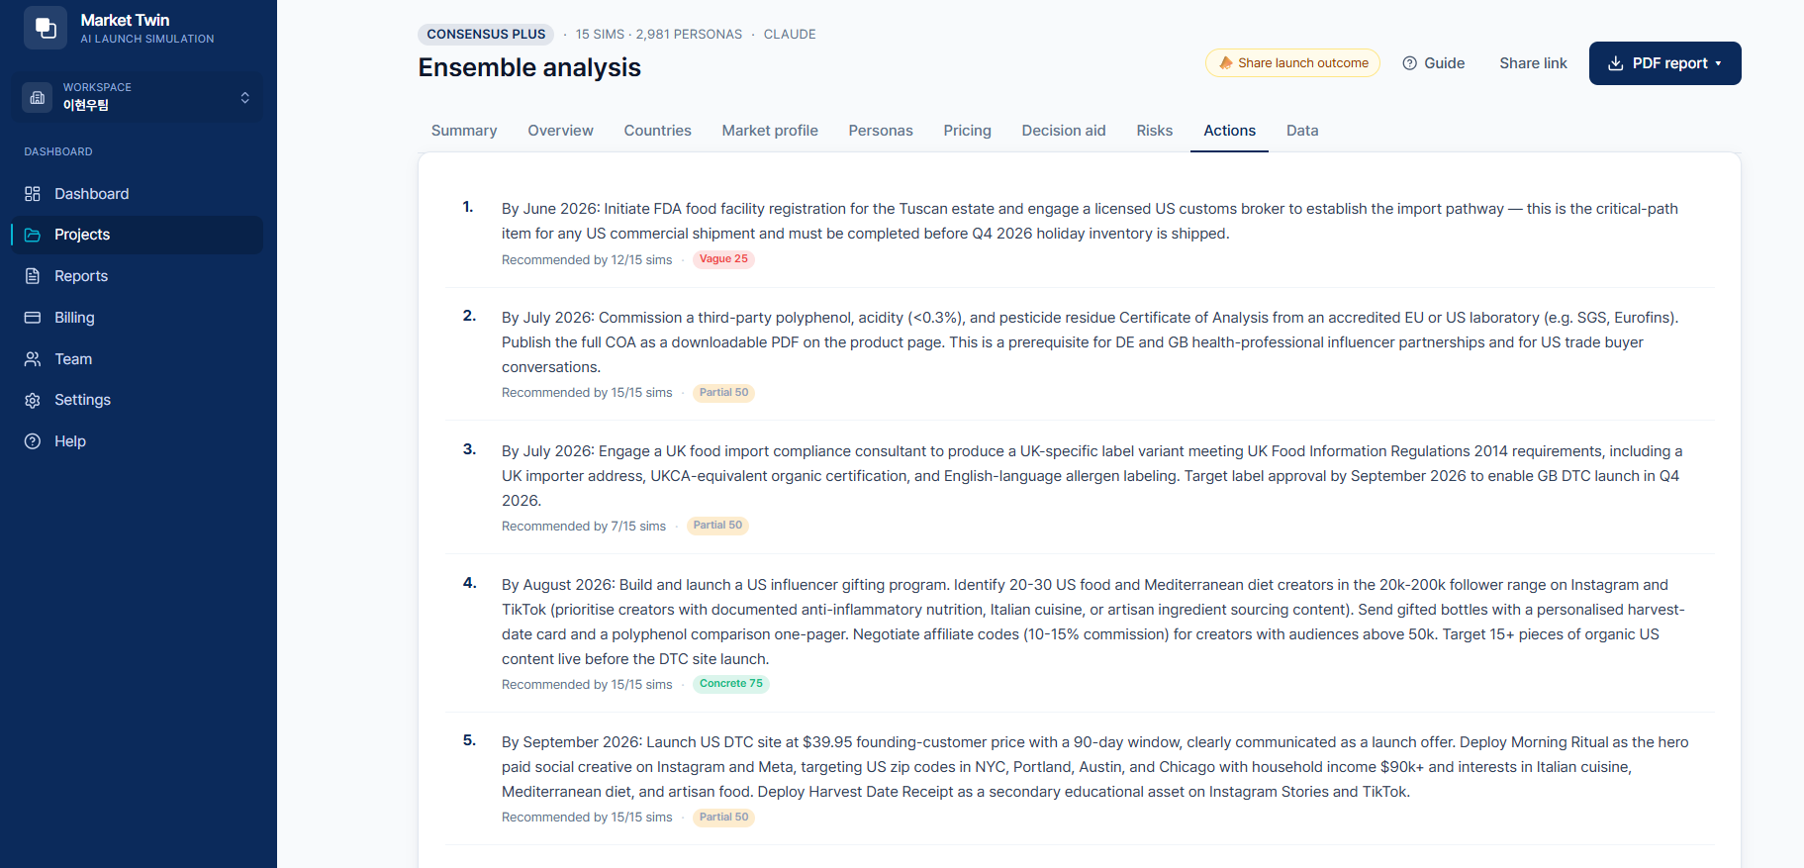
Results — recommended action priority matrix

6.7 Beta Feedback
At the bottom of the results screen, send feedback via “Was this result useful for your decision?” (1–5) plus a one-line comment. Your input goes straight into improving the product.

7. Asking a Persona
Click “Ask” on any persona card to ask that persona a natural-language question and get a first-person answer (e.g. “Which channel do you prefer to buy from?”). You can directly probe purchase motivation, channel preference, and objection reasons that quantitative stats alone can’t reveal.
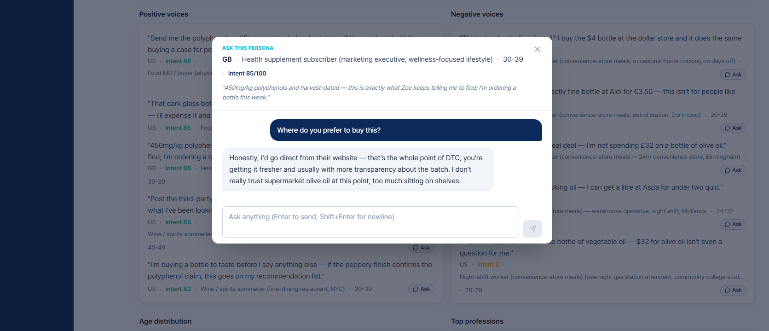
Persona Q&A

8. PDF Reports
From PDF Report at the top right of the results screen, download three formats by purpose.
Type | Length | Use
Executive | 2–3 pages | Hot take, recommended country, key actions, pricing (exec briefing)
Full analysis | ~30 pages | Investment+ROI, recommendation robustness, intent by occupation, channel priority, risk × action
Cross-validation | McKinsey/BCG style | Consistency with external market data, confidence grade, staged execution
A report flows: consensus opinion → market situation + competitors → GTM strategy summary → 30/60/90-day execution timeline → per-country detail.
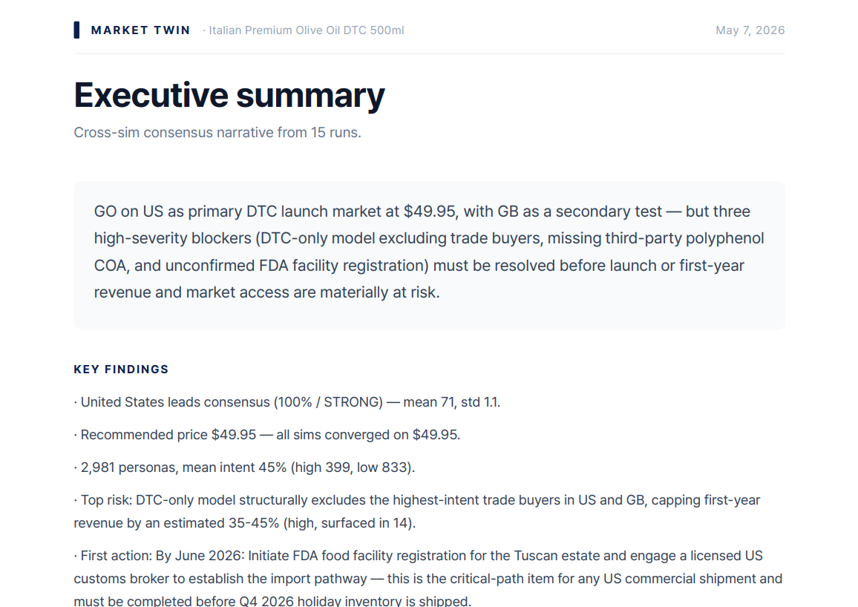
PDF report — consensus opinion
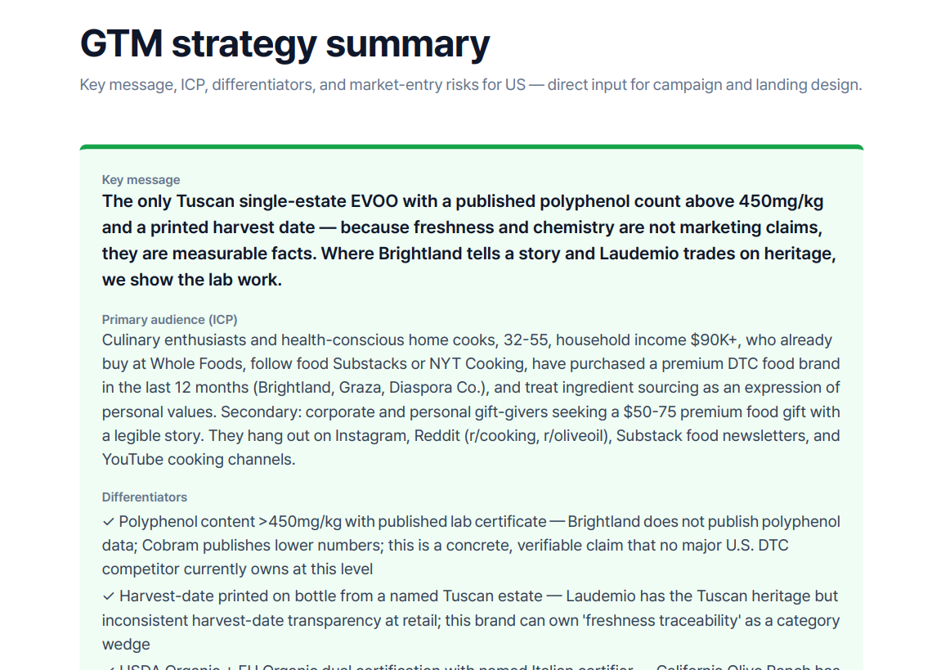
PDF report — GTM strategy / 30·60·90-day timeline

9. Settings
Manage your profile, workspace, and notifications under Settings in the left menu.
Area | Items
Profile | Email, display language (Korean/English)
Workspace info | Name, company, industry, country (shown on results page / PDF header)
Plan / created | Current plan and workspace creation date
Email notifications | Receive results at your registered email on simulation completion/failure
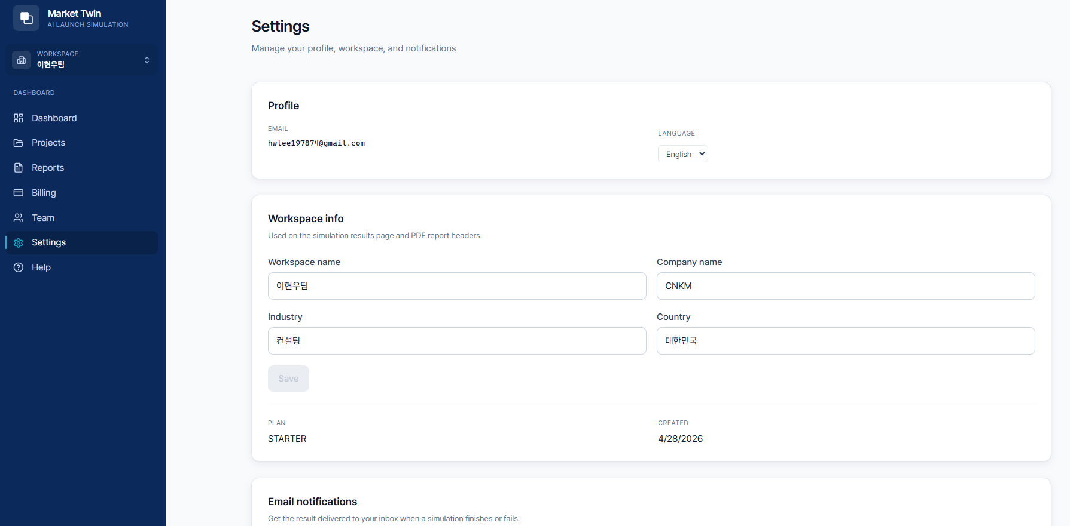
Settings

10. Frequently Asked Questions (FAQ)
Q. How long do results take? The sample demo takes 2–3 minutes; a real product validation usually a few minutes. Results are kept even if you close the screen.
Q. What’s free? During the beta, 7 days or 2 hypothesis validations are free, with no credit card. The sample demo is available 3 times a day separately.
Q. Does the sample demo count against my free runs? No. The sample demo is separate from your free validation runs.
Q. Is my product information safe? For simulation inference, it is sent to overseas LLM providers, per the cross-border transfer notice you agreed to at sign-up. Payment card details are not stored (tokenized by the PG).
Q. Can I share results with my team? Yes. Share via the results-screen link, or invite teammates to your workspace and collaborate by role (owner/admin/analyst/viewer).

11. Troubleshooting
Symptom | Action
Verification email not arriving | Check spam → “Resend confirmation email” (60s interval) → still nothing, contact contact@markettwin.ai
Can’t log in | Check your sign-up method (Google/email) and whether email verification is complete
Simulation seems stuck | It keeps running in the background even if you close the screen. Check the results page shortly.
Results look off | Check you didn’t put external facts (sales/share) in the description (see §4.1 caution)
Recommendation skews to one country | Check the description/inputs for phrasing that implies a specific country

12. Glossary
Term | Meaning
Launch success score | 0–100 composite based on demand, CAC, competitive intensity
Persona | A virtual local consumer generated from government statistics
Purchase intent | A persona’s intent-to-buy score (0–100)
Ensemble | Running multiple independent simulations in parallel to raise reliability
TAM | Total Addressable Market
CAC | Customer Acquisition Cost
M:R | Marketing-to-Revenue ratio
LTV | Life-Time Value
BREAK-EVEN | Break-even point
GTM | Go-To-Market strategy
Hypothesis | The base analysis tier offered in the free trial

13. Support & Contact
- Email: contact@markettwin.ai
- Operated by: Mr.AI Inc. (주식회사 미스터에이아이)
- Found a bug or have an improvement idea during the beta? Email us anytime and we’ll fold it into the product.
Screens in this manual may differ slightly by product version. © 2026 Mr.AI Inc.

